TECHNICAL PROPOSAL
Mathematics Learning Game Application
for Primary-Age Children in Myanmar
Prepared in response to Annex B ToR and Clarifications
Offline-first cross-platform educational game application covering Grades 1-5, English/Myanmar language support, diagnostic learning progression, gamified practice, and secure local progress management.

Project | Mathematics Learning Game Application
Client | UNICEF
Proposal Type | Technical Proposal

1. Executive Summary
This proposal presents a practical and implementation-focused approach to develop a new Mathematics Learning Game Application for primary-age children in Myanmar. The solution is planned as an offline-first cross-platform mobile application for Android and iOS, with a stage-based learning journey, learner profile management on shared devices, diagnostic starting level configuration, concept-learning activities, drill-and-practice, mastery assessment, gamification, bilingual English/Myanmar support, and secure local progress storage. The delivery approach follows the ToR deliverable structure from prototype specification through Alpha, Beta, and final production-ready release.

2. Understanding of Requirement
Based on the ToR, the application is intended for Grades 1 to 5 and must develop foundational numeracy skills through a learning cycle of concept explanation, game-based interaction, drill-and-practice, and unit mastery evaluation. The application must operate fully offline after installation, with no runtime backend dependency, and must support multiple learners on a shared device with separate progress, settings, and safe adult controls.
- Approximate content scale: around 30 Learning Domains, 150 Units, and about 5,000 Lessons.
- Core learning inputs: tap, drag-and-drop, and numeric entry using on-screen and device keyboard options.
- Core flows: learner setup, diagnostic test, stage progression, resume from latest point, and optional lesson library practice mode.
- Language scope: English and Myanmar; UNICEF will provide source content in English and the vendor is expected to translate into Myanmar.
- Content responsibility: UNICEF will provide question specifications with sample questions; the vendor is expected to build the technical mechanism to generate or integrate questions aligned with those specifications.

3. Proposed Technical Approach

3.1 Solution Strategy
The proposed solution is a 2D game-based mobile application built from scratch using a dedicated game engine. The primary implementation strategy is to use Unity for a single maintained codebase that exports to both Android and iOS. This approach is well aligned with the requirement for interactive concept-learning stages, responsive drag-and-drop activities, gamification, audio switching, and strong offline packaging while keeping maintenance practical for future UNICEF updates and country adaptation.

3.2 Offline-First Application Design
The live application will have no backend dependency during normal operation. All lesson content, localization resources, audio, learner progress, rewards, and configuration needed for gameplay will be packaged into the installable build or approved local content packages. Local storage will be used for learner profiles, stage progress, diagnostic results, lesson completion, and settings. No external analytics, advertising, or telemetry service will be included.

3.3 Content and Lesson Delivery Model
Because UNICEF will provide question specifications progressively, the application will be built with a structured content framework. Each lesson will be defined through reusable templates and rule-driven question logic so that content can be expanded at scale without re-engineering the whole application. This is important for managing approximately 5,000 lessons while keeping the solution maintainable and consistent.

3.4 Child-Friendly Learning Experience
The visual interaction model will be intentionally simple, low-text, and highly guided so that learners can navigate independently. The primary experience will move from onboarding and language selection to diagnostic placement, then to concept learning, skill practice, mastery checks, and progress-based advancement. Visual progress indicators, rewards, and clear retry guidance will be used to reinforce continued learning without creating unnecessary UI complexity.

3.5 Security and Compliance Approach
Security will be addressed through secure-by-default development practices, restricted permissions, protected local data, dependency review, secure signing, environment access control, and independent mobile application security assessment before final acceptance. UNICEF-owned source code, builds, and project assets will be organized for clean handover and future maintainability.

4. Proposed Technical Stack
Layer | Proposed Stack | Rationale
Application Engine | Unity | Suitable for game-like interactions, drag-and-drop, animations, reward effects, and single-codebase Android/iOS deployment.
Mobile Platforms | Android and iOS build targets | Required deployment targets under the ToR.
UI & Localization | Unity UI framework, localization tables, font fallback support | Supports bilingual English/Myanmar display and child-friendly screen design.
Local Data | Encrypted local persistence and platform-secure storage for sensitive settings | Supports offline learner profiles, progress, settings, and resume flows.
Content Framework | Structured lesson configuration using JSON / ScriptableObject driven content definitions | Enables large-scale lesson rollout and maintainable content updates.
Audio | Compressed offline audio assets with language-based switching | Supports English and Myanmar voice/audio where included.
Version Control | Git-based repository management | Supports traceability, controlled collaboration, and handover readiness.
Build & Release | Android Studio / Xcode toolchain with signed builds | Needed for APK/IPA generation and release readiness.
QA & Security | Manual QA, device compatibility testing, defect tracking, dependency review, and independent mobile security assessment | Aligned with ToR testing and security expectations.

5. Solution Architecture Diagram
The following diagram presents the recommended high-level architecture for a fully offline learning application with cross-platform mobile delivery, structured lesson content, secure local data handling, and controlled build/security processes.
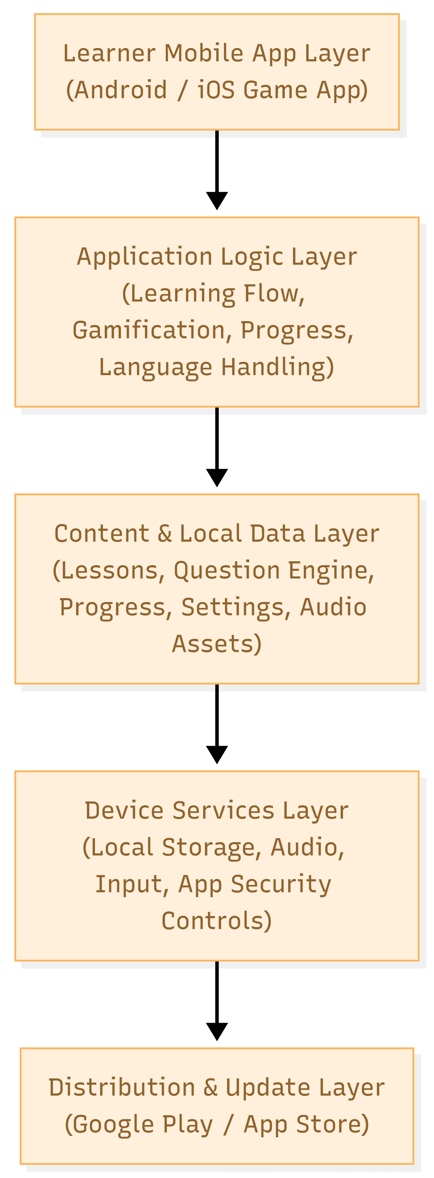
Figure 1. High-Level Solution Architecture

6. Learning Session Flow Diagram
The proposed learner experience follows the educational flow reflected in the ToR: start-up and learner selection, diagnostic placement, concept learning, practice, mastery assessment, and local progress continuity.
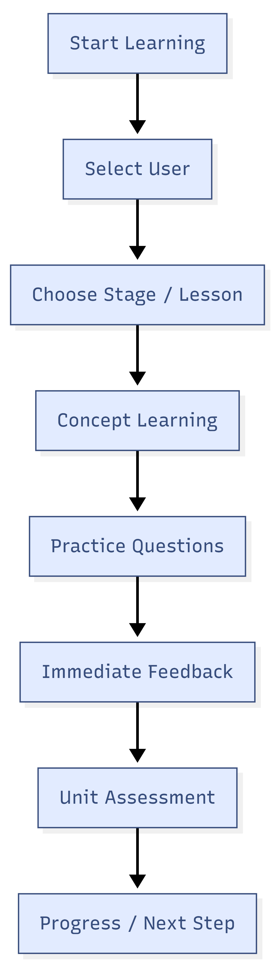
Figure 2. Indicative Learning Session Flow

7. Development Methodology

7.1 Delivery Model
A phased iterative delivery model will be used, aligned directly to UNICEF's deliverables: Kick-off, Prototype Specifications, Application Foundation and Prototype, Alpha Specifications, Alpha Application, Beta Specifications, Beta Application, and Final Version.

7.2 Working Method
Each phase will combine requirement refinement, UX flow detailing, lesson template implementation, build development, internal QA, UNICEF review incorporation, and controlled handover of outputs. Because content specifications are expected progressively, the implementation approach will separate engine/framework work from lesson-content expansion so the team can continue building core capability while integrating new content batches.

7.3 Quality Gates
Each major deliverable will pass internal quality gates before submission: scope completeness check, functional testing, device compatibility verification, localization review, offline verification, defect triage, and submission package review.

7.4 Collaboration with UNICEF
Bi-weekly progress meetings, milestone demonstrations, submission notes, issue logs, and revision tracking will be maintained. Feedback cycles will be managed through controlled change review so that each deliverable remains traceable to the approved scope.

8. Key Functional Scope to be Implemented
Module / Area | Included Scope
Learner Profiles | Multiple learner profiles on one device, avatar/icon selection, nickname, separate progress and settings, delete/reset options.
Initial Setup | First-launch language selection and simple visual guidance for children.
Diagnostic Setup | Diagnostic test, starting level configuration, saved result per learner, adult-adjustable starting level.
Learning Progression | Stage-based progression with lesson resume from latest point or recommended next lesson.
Question Handling | Tap, drag-and-drop, and numeric input question types with immediate answer validation.
Concept Learning | Interactive learning screens that demonstrate number concepts and support discovery-based understanding.
Practice & Retry | Drill-and-practice exercises, retry flow, and corrective feedback.
Unit Mastery | End-of-unit mastery assessment and next-step recommendation.
Gamification | Rewards, stage completion celebration, unlock conditions, and visible progression cues.
Progress Visualisation | Stage status, unit-level status, learning time record, and recommended path cues.
Settings & Data | Language and volume settings, learner data reset, and shared-device data management.
Adult Controls | Restricted adult or facilitator actions through protected access methods.
Lesson Library | Independent lesson review or practice mode without affecting locked progression rules.
Localization | English and Myanmar content and audio switching.
Distribution | APK and App Store submission-ready builds with versioning and release traceability.

9. Deliverables
ID | Deliverable | Short Description
D1 | Kick-off Completion Package | Project plan, governance approach, and mobilization package.
D2 | Prototype Specifications | Prototype UX or user flow, initial data specifications, one concept-learning specification, one drill-and-practice specification, and prototype schedule.
D3 | Application Foundation and Prototype | Core application foundation with learner management, save or load, navigation flow, one concept-learning game type, and one drill-and-practice exercise type.
D4 | Alpha Specifications | Expanded specifications for Alpha content, core features, architecture notes, data and storage design, security notes, and schedule.
D5 | Alpha Version Application | Functional Alpha with three multiplication units, lesson progression, diagnostics, feedback, rewards, and bilingual support.
D6 | Beta Specifications | Complete UX or UI, lesson content, asset specifications, and Beta plan.
D7 | Beta Version Application | Complete version with all Units and Lessons implemented, all major workflows functional, and distribution artifact for internal testing.
D8 | Final Version and Close-out | Final production-ready version, source code, editable assets, security assessment outputs, test report, build procedure, guides, and final report.

10. Testing and Quality Assurance
- Functional Testing: Validation of all learner journeys, stage progression, question interaction types, save and resume flow, lesson library mode, settings, adult controls, and bilingual switching.
- Content Integrity Testing: Verification that lesson rules, generated or integrated questions, mastery logic, rewards, and unlock conditions match the approved specifications.
- Offline Testing: Repeated validation of all core flows without internet connectivity, including fresh install, returning learner, resume, and multi-user device scenarios.
- Device Compatibility Testing: Testing across representative Android and iOS devices and screen sizes using reasonable market assumptions for performance and usability.
- Localization Testing: English and Myanmar text rendering, font behavior, layout verification, and language-specific audio switching review.
- Performance Testing: App launch, scene transitions, input responsiveness, storage behavior, and long-session stability on low-to-mid tier devices.
- Security Testing: Code-level secure development checks, dependency review, build signing verification, local data protection review, and independent mobile application security assessment before final acceptance.
- Pilot Support QA: Issue tracking, prioritization, fix verification, and controlled regression checks during UNICEF pilot review and partner feedback stage.


11. Key Assumptions and Dependencies
- UNICEF will provide learning domain or unit specifications and sample question logic in document form, progressively during development.
- UNICEF source content will be provided in English; Myanmar translation is included in the implementation scope.
- The final Beta version is expected to include the full content volume, approximately 5,000 lessons.
- No production backend, online services, analytics, or cloud dependency will be required for normal application use.
- Detailed minimum target device specifications are not yet defined; reasonable device assumptions will be finalized during mobilization.
- Independent security assessment will be scheduled before final acceptance.

12. Conclusion
This proposal recommends a focused, scalable, and maintainable delivery approach for the Mathematics Learning Game Application, keeping strictly within the defined requirement scope while ensuring the application is robust enough for full offline use, bilingual learning delivery, large-scale lesson implementation, child-friendly interaction, and secure final handover. The recommended Unity-based cross-platform approach balances interactive learning quality, long-term maintainability, and controlled delivery for the complete UNICEF milestone structure.

